|  |
| --- |
| June Patrick Dacaya |

Smart-Home with Solar Monitoring Entry 0NC

Status

/1 Hardware present?

/1 Title Page

/1 Declaration of Joint Authorship

/1 Proposal (500 words)

/1 Executive Summary

# Declaration of Joint Authorship

We, June Patrick Dacaya, Adrian De Braga, Bao Quy Diep, and Nam Nguyen confirm that this work submitted is the joint work of our group and is expressed our own words. Any uses made within it of the works of any other author, in any form (ideas, equations, figures, texts, tables, programs), are properly acknowledged at the point of use. A list of the references used is included. The work breakdown is as follows: Each of us provided functioning, documented hardware for a sensor or effector. I and Adrian provided PLC functionalities and a Temperature sensor. Bao provided another temperature sensor. Nam provided a light sensor. In the integration effort Nam is the lead for further development of our mobile application, June and Adrian is the lead for the Hardware, and Bao is the lead for connecting the two via the Database.

# Proposal

We have created a mobile application, worked with databases, completed a software engineering course, and prototyped a small embedded system with a custom PCB as well as an enclosure (3D printed/laser cut). Our Internet of Things (IoT) capstone project uses a distributed computing model of a smart phone application, a database accessible via the internet, an enterprise wireless (capable of storing certificates) connected embedded system prototype with a custom PCB as well as an enclosure (3D printed/laser cut) and are documented via this technical report targeting OACETT certification guidelines.

Intended project key component descriptions and part numbers  
Development platforms: Nucleo-F401RE running the STM32 chip, Arduino, Raspberry Pi, and Blue pill with Arduino IDE.  
Sensor/Effector 1: PLC functionalities performed by NUCLEO Wi-Fi PLC Stackable components with Temperature sensor, RTD PT100 with a 4-20 ma transmitter, which is one of the most accurate temperature sensor in the market, it is also almost immune to electrical noise which makes it more suitable in an industrial environments. The PLC functions will be performed by three components: X-NUCLEO-PLC01A1 which performs basic PLC input/output functions, X-NUCLEO-OUT01A1 which is another input/output component which supports voltage of up to 24V, and an X-NUCLEO-IDW01M1 which supports internet connectivity through a Wi-Fi connection.

Sensor/Effector 2: MCP9808 is an I2C temperature sensor which will be used to monitor the temperature indoor. It is one of the more precise temperature sensors in the IoT world.  
Sensor/Effector 3: VEML 7700 ambient light sensor which runs in Arduino. A light sensor that will be used to monitor luminosity indoor/outdoor.

Sensor/Effector 4: RPI 8MP CAMERA BOARD is an 8 mega-pixel high resolution camera which will be use to record/snap images of the home’s surroundings.

We will continue to develop skills to configure operating systems, networks, and embedded systems using these key components to create a smart house that will have a solar panel activity monitoring as well as to monitor in-house temperature, security system, and a unique user base data available through a cloud base database. The Wi-Fi PLC component will be used to monitor the solar panels in conjunction with the RTD P100 outside a smart house. The temperature sensor will be used to manage the house temperature and the light sensor will be used to monitor and control the lights installed in the house. All the functionalities of the smart house will be monitored through an android mobile application which users can download. The user’s mobile application will have the eyes and controls for the smart house.

Our project description/specifications will be reviewed by, Kim Huynh from Alpha Lab, ideally an employer in a position to potentially hire once we graduate. They will also ideally attend the ICT Capstone Expo to see the outcome and be eligible to apply for NSERC funded extension projects. This typically means that they are from a Canadian company that has been revenue generating for a minimum of two years and have a minimum of two full time employees.

The small physical prototypes that we build are to be small and safe enough to be brought to class every week as well as be worked on at home. In alignment with the space below the tray in the Humber North Campus Electronics Parts kit the overall project maximum dimensions are 12 13/16" x 6" x 2 7/8" = 32.5cm x 15.25cm x 7.25cm.

Keeping safety and Z462 in mind, the highest AC voltage that will be used is 16Vrms from a wall adapter from which +/- 15V or as high as 45 VDC can be obtained. Maximum power consumption will not exceed 20 Watts. We are working with prototypes and that prototypes are not to be left powered unattended despite the connectivity that we develop.

# Executive Summary

This document will guide the future investors about our Smart-House Project. The project will be smart house that will be control just by using an android mobile application. Users will have their own personal data securely stored in the cloud while having a complete access to it. Users will be able to monitor their solar panels, doors, indoor temperature, and surroundings with just a tap in the app. The mobile application is their window to their house while being at work or at home. The smart house project will be complete in conjunction with the hardware components such as temperature sensors, light sensors, motors, and camera. The smart house project aims to be a complete, secure, and a mobile project. The main goal for this project is to have a secured, automated, and accessible for the users.

Contents

Declaration of Joint Authorship 3

Proposal 5

Executive Summary 9

List of Figures 13

1.0 Introduction 15

1.1 Scope and Requirements 15

2.0 Background 19

3.0 Methodology 23

3.1 Required Resources 23

3.1.1 Parts, Components, Materials 23

3.1.2 Manufacturing 23

3.1.3 Tools and Facilities 23

3.1.4 Shipping, duty, taxes 23

3.1.5 Time expenditure 23

3.2 Development Platform 23

3.2.1 Mobile Application 23

3.2.2 Image/firmware 25

3.2.3 Breadboard/Independent PCBs 25

3.2.4 Printed Circuit Board 27

3.2.5 Enclosure 28

3.3 Integration 29

3.3.1 Enterprise Wireless Connectivity 30

3.3.2 Database Configuration 30

3.3.3 Security 30

3.3.4 Testing 30

4.0 Results and Discussions 31

5.0 Conclusions 33

6.0 References 35

7.0 Appendix 37

7.1 Firmware code 37

7.2 Application code 37

# List of Figures

Figure 1. By Android Studio - https://developer.android.com/studio/, CC BY-SA 4.0, https://commons.wikimedia.org/w/index.php?curid=74094999 24

Figure 2. Initial schematic. This work is a derivative of "http://fritzing.org/parts/" by Fritzing, used under CC:BY-SA 3.0. 26

Figure 3. This work is a derivative of "http://fritzing.org/parts/" by Fritzing, used under CC:BY-SA 3.0. 26

Figure 4. Breadboard prototype. 27

Figure 5. PCB design This work is a derivative of "http://fritzing.org/parts/" by Fritzing, used under CC:BY-SA 3.0. 28

Figure 6. Humber Sense Hat Prototype PCB. 28

Figure 7. Example enclosure. 29

# 1.0 Introduction

Nowadays, Smart Home is getting popular to people. Modern and new technologies are coming out every day in order to support people. Smart Home is an application that could help people to overview and control their house efficiency way. The structure of smart home application consists of sensor and application layer. The sensor gets the primitive data from the house that monitored by using various sensor and user input. Then the primitive data is stored in the database. The application layer displays the database that users request for. There are some advantages that users have when they use the smart home app. First one is energy efficiency; user can adjust the thermostat of their house on their way home to control the temperature so when they get home, they don’t feel cold in the house. That is about energy efficiency. Secondly, smart home helps to save energy and money. When people leave the kitchen without turning the light off, the light will turn itself off. So, no more energy will be wasted. In addition, it helps the home owners have more security about their house. When people walk out of their house and five minutes later, they don’t remember if they lock the door so they can open the app and check it then lock it easily. The Smart-Home system will also to monitor solar panel activity and its history.

## 1.1 Scope and Requirements

It is an Internet of Things (IoT) capstone project that uses a distributed computing model of a smart phone application that was developed in the previous months and will be constantly updated, it will support database access via the internet to read and display data as well as control various functionalities for example: turning the lights off. It will incorporate closely with an enterprise wireless (capable of storing certificates) connected embedded system prototype with a custom PCB for sensors we provide: luminosity sensor, temperature sensor, and camera as well as an enclosure (3D printed/laser cut) for the project. The project will be documented via an OACETT certification acceptable technical report that will have a minimum of 9000 words. We will not be doing a CSA testing for this project because we are only making a prototype of a bigger project.

Here are our prototype specification,

Mobile Application Specification:

* Developed using Android Studio
* Supports API version 21 (Lollipop)
* Supports database connectivity
* Internet Connection

Database Specification:

* Firebase database
* Real-time database
* NoSQL functionalities

Hardware Specification:

* PCB will be developed/organized using Fritzing.
* Custom PCB will be printed in our Prototype Laboratory
* Enclosure will be printed in our Prototype Lab or an 3D printing company.
* Should not be left unattended
* Assembled in our classroom

Report

/1 Hardware present?

/1 Introduction (500 words)

/1 Scope and Requirements

/1 Background (500 words)

/1 References

# 2.0 Background

We would like to thank our collaborator Kim Huynh from Alpha Lab for supporting this project. Our Smart Home with Solar Monitor will have an X-NUCLEO-OUT01A1 which is going to be where all the components will be connected to (Beningo, 2018). The RTD pt100 and 4-20 mA transmitter (Administrator, 2016) will be connected to a Wheatstone bridge/differential amplifier to find the voltage/temperature difference of the sensor. We have another temperature sensor, the MCP9808 which is an I2C sensor which can be used to compare the temperature between the RTD (Rudi, 2019), to find a more exact temperature. A VEML 7700 ambient light sensor to monitor the light level (Rembor, 2019). All these sensor/effectors will be connected to the PLC which will have a wireless connection to our app. The mobile app will have a real-time database storing the readings it receives from the sensors. The smart house’s main goal is to have a secure and automated system for the home owners.

In the Computer Engineering Technology program we have learned about the following topics from the respective relevant courses:

* Java Docs from CENG 212 Programming Techniques In Java,
* Construction of circuits from CENG 215 Digital And Interfacing Systems,
* Rapid application development and Gantt charts from CENG 216 Intro to Software Engineering,
* Micro computing from CENG 252 Embedded Systems,
* SQL from CENG 254 Database With Java,
* Web access of databases from CENG 256 Internet Scripting; and,
* Wireless protocols such as 802.11 from TECH152 Telecom Networks,
* Creating Android Mobile Application with a realtime database from CENG319,
* PCB creation and casing as well as documenting our works from CENG318

This knowledge and skill set will enable us to build the subsystems and integrate them together as our capstone project.

The problem solved by this project is to make life easier by starting a home automation system. Our proposal requests the approval to build a model house that will connect to a database as well as to a mobile device application.

In relation to the project, this semester we plan to complete a prototype of a smart home system.

Potentially, the project will include the following software attributes and design as for the application side of the project in the following sequence from startup:

A login screen which will feature a logo of a house & security related symbol and our team name.

Log in screen will employ the typical login and password functionality tied to the database.

A menu which will contain the following tabs

* Temperature – showing the temperature of the location of the sensor
* Lighting – control and observe the status of lighting
* Camera – showing the video side of the house, optimally control to move the camera
* Door – status and history of the door and optimally control (locked or unlocked)
* Ventilation – status and control of the ventilation
* Help/About – will be a link to a website describing user functionality and contact info

The design will be as simple as possible for the user. We will use menu buttons, text views and various other android studio functionalities which we will learn in this class for this. The UI should provide audible and visual alerts and notifications to the user to any changes in the system of the house which will persist until the user sees them as a measure of security and consistency.

The database we plan to use is Firebase for now as it seems simple and intuitive.

The time estimation for this project is as per the following schedule:

Fall Semester – Software Application, Database Integration and Hardware Practicality

Winter Semester – Software/Hardware Integration and Hardware Modeling

There a few similar projects on the market as this is currently a popular idea in undertaking by big companies, some of the apps similar to our project are:

SmartHome, Rogers Smart Home Monitoring, Samsung Smart Home

Our goal is to try to make a simpler, faster, friendlier and cheaper model.

# 3.0 Methodology

## 3.1 Required Resources

Report

/1 Parts/components/materials (500 words)

/1 PCB, case (500 words)

/1 Tools, facilities (500 words)

/1 Shipping, duty, taxes (250 words)

/1 Working time versus lead time (250 words)

### 3.1.1 Parts, Components, Materials

### 3.1.2 Manufacturing

### 3.1.3 Tools and Facilities

### 3.1.4 Shipping, duty, taxes

### 3.1.5 Time expenditure

Working time versus lead time.

## 3.2 Development Platform

### 3.2.1 Mobile Application

Status

/1 Hardware present?

/1 Memo by student A + How did you make your Mobile Application? (500 words)

/1 Login activity

/1 Data visualization activity

/1 Action control activity

Include screenshots such as Figure 1. Testing. Progress.

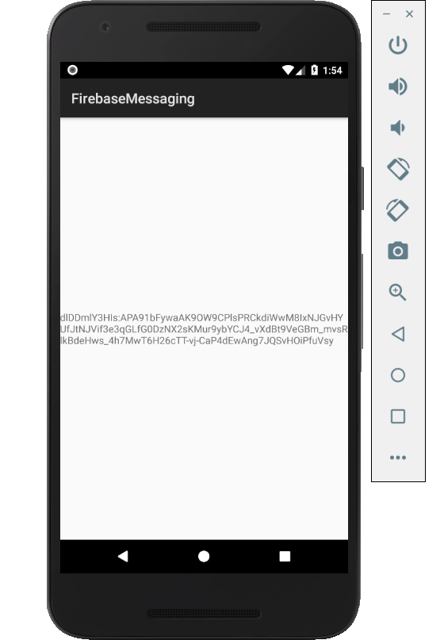

Figure 1. By Android Studio - https://developer.android.com/studio/, CC BY-SA 4.0, https://commons.wikimedia.org/w/index.php?curid=74094999

### 3.2.2 Image/firmware

Status

/1 Hardware present?

/1 Memo by student B + How did you make your Image/firmware? (500 words)

/1 Code can be run via serial or remote desktop

/1 Wireless connectivity

/1 Sensor/effector code on repository

### 3.2.3 Breadboard/Independent PCBs

Status

/1 Hardware present?

/1 Memo by student C + How did you make your hardware? (500 words)

/1 Sensor/effector 1 functional

/1 Sensor/effector 2 functional

/1 Sensor/effector 3 functional

The initial schematic design, Figure 2, based on datasheets led to a breadboard layout Figure 3 that was realized Figure 4.

How did you build your Prototype: Breadboard?

Then a PCB was designed, Figure 5, and populated (Figure 6). Bill of Materials, Case, Time commitment. Testing. Progress.

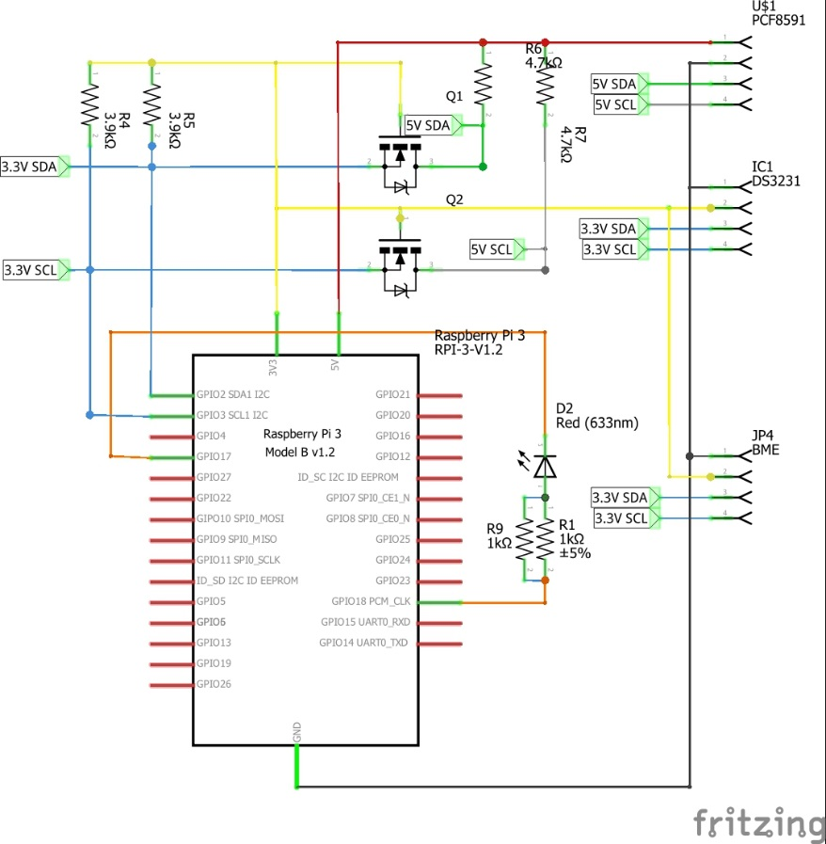

Figure 2. Initial schematic. This work is a derivative of "http://fritzing.org/parts/" by Fritzing, used under CC:BY-SA 3.0.

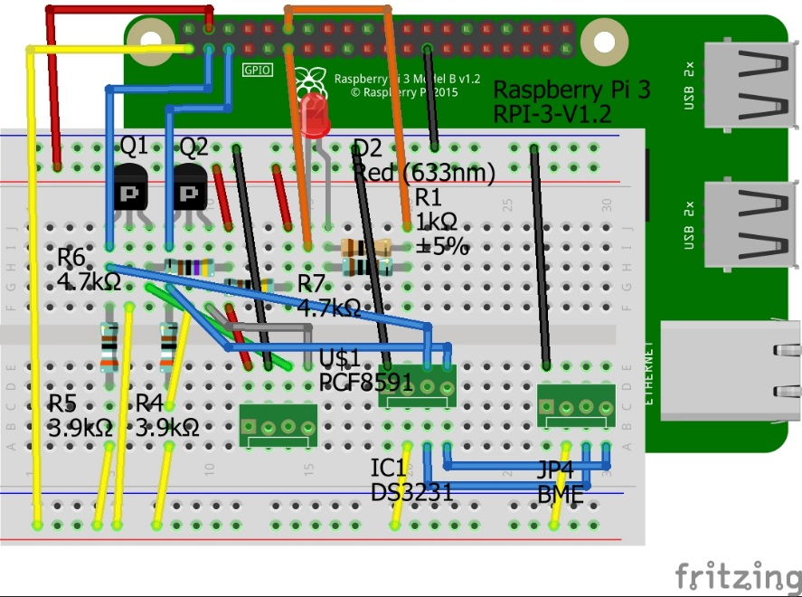

Figure 3. This work is a derivative of "http://fritzing.org/parts/" by Fritzing, used under CC:BY-SA 3.0.

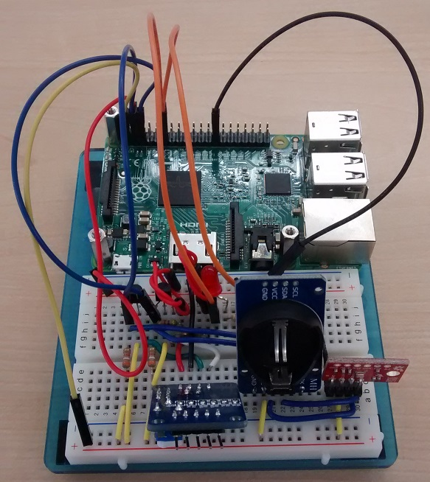

Figure 4. Breadboard prototype.

### 3.2.4 Printed Circuit Board

Demo

/1 Hardware present?

/1 PCB Complete and correct

/1 PCB Soldered wire visible but trim, no holes or vacancies

/1 PCB Tested with multimeter

/1 PCB Powered up

How did you build your Prototype: PCB?

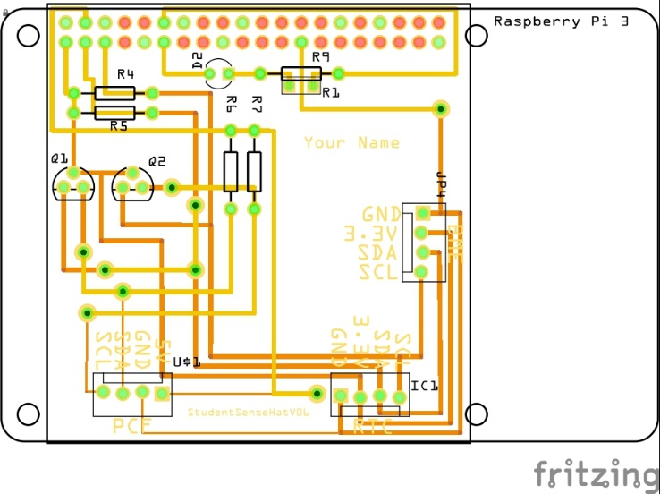

Figure 5. PCB design This work is a derivative of "http://fritzing.org/parts/" by Fritzing, used under CC:BY-SA 3.0.

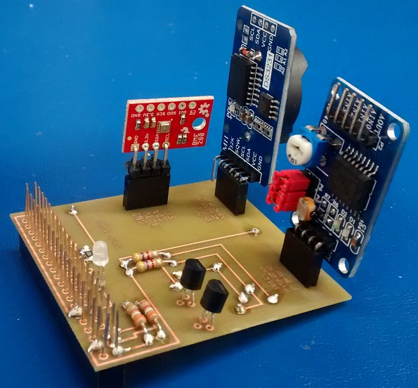

Figure 6. Humber Sense Hat Prototype PCB.

### 3.2.5 Enclosure

Demo

/1 Hardware present?

/1 Case encloses development platform and custom PCB.

/1 Appropriate parts securely attached.

/1 Appropriate parts accessible.

/1 Design file in repository, photo in report.

How did you build your Prototype: Case?

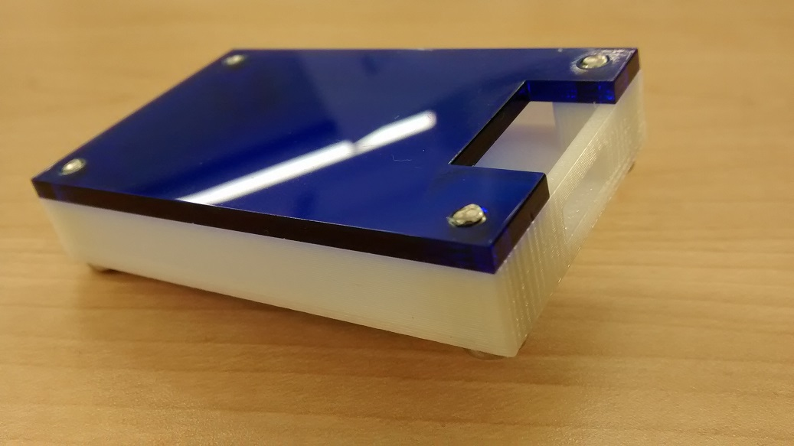

Figure 7. Example enclosure.

## 3.3 Integration

Demo

/1 Hardware present?

/1 Data sent by hardware

/1 Data retrieved by mobile application

/1 Action initiated by mobile application

/1 Action recieved by hardware

Report

/1 Enterprise wireless connectivity (250)

/1 Database configuration (250 words)

/1 Security considerations (500 words)

/1 Unit testing (900 words)

/1 Production testing (100 words)

### 3.3.1 Enterprise Wireless Connectivity

How did you make a Database accessible by both your Prototype and Mobile Application?

### 3.3.2 Database Configuration

### 3.3.3 Security

### 3.3.4 Testing

Unit testing and Production testing.

# 4.0 Results and Discussions

Is your prototype perfect? What did you learn?

# 5.0 Conclusions

If you were making 1000 of these.

Report

/1 Hardware present?

/1 Checklist truthful

/1 Valid Comments

/1 Results and Discussion (500 words)

/1 Conclusion

# 6.0 References

Administrator. (2016). *Temperature sensor from RTD PT100 4-20mA transmitter and Arduino*. Retrieved from http://www.absolutelyautomation.com/articles/2016/02/09/temperature-measurement-rtd-pt100-4-20ma-transmitter-and-arduino.

Beningo, J. (2018). *Creating a Custom Wireless Programmable Logic Controller (PLC)*. Retrieved from https://www.digikey.ca/en/articles/techzone/2018/jun/creating-a-custom-wireless-programmable-logic-controller

Kinsella, J. (2019). Five trends predicted for the cloud industry in 2019. *Software World*, 50(1), 11.

Media, O. (2019). *O'Reilly artificial intelligence conference 2019 - San Jose, California.* California: O'Reilly Media, Inc.

OACETT. (2017, March). *I need to Complete a Technology Report*. Retrieved from The Ontario Association of Certified Engineering Technicians and Technologists: https://www.oacett.org/Membership/Technology-Report-and-Seminar

Rembor, K. (2019). *Adafruit VEML7700 Ambient Light Sensor*. Retrieved from https://learn.adafruit.com/adafruit-veml7700/overview

Rudi, M. (2019). *Reading Temperature Data from a MCP9808 using a Raspberry Pi*. Retrieved from https://forum.digikey.com/t/reading-temperature-data-from-a-mcp9808-using-a-raspberry-pi/4962

# 7.0 Appendix

## 7.1 Firmware code

Demo

/1 Hardware present?

/3 Code runs concurrently for all sensors/effectors

/1 Project repository contains integrated code

Status

/1 Memo including updates

/1 Financial update

/1 Progress update

/1 Modified Code Files in Appendix

/1 Link to Complete Code in Repository

## 7.2 Application code

Demo

/1 Hardware present?

/1 Memo by student A

/1 Login activity

/1 Data visualization activity

/1 Action control activity

Report

/1 Login activity

/1 Data visualization activity

/1 Action control activity

/1 Modified Code Files in Appendix

/1 Link to Complete Code in Repository